EXPT NO:7B | DATA VISUALIZATION USING TABLEAU

AIM:
To import, transform, analyze, and visualize the Diabetes Prediction dataset using Tableau Desktop and create interactive dashboards and reports to understand diabetes-related patterns and support data-driven decision-making.

ALGORITHM:
- Start
- Open Tableau Desktop.
- Connect to the Diabetes Prediction dataset.
- Import and check the data.
- Clean and transform the data if required by handling missing values, duplicate records, and incorrect data types.
- Create worksheets using suitable fields such as Age, Gender, BMI, HbA1c Level, Blood Glucose Level, Hypertension, Heart Disease, Smoking History, and Diabetes.
- Create visualizations such as bar charts, line charts, pie charts, scatter plots, and tables to analyze the dataset.
- Create visualizations to study the relationship between blood glucose level, HbA1c level, BMI, age, and diabetes status.
- Combine the worksheets to create an interactive dashboard.
- Add filters and slicers for fields such as Gender, Age, Smoking History, Hypertension, Heart Disease, and Diabetes for better analysis.
- Analyze the dashboard and identify important insights and patterns related to diabetes prediction and patient health characteristics.

OUTPUT:

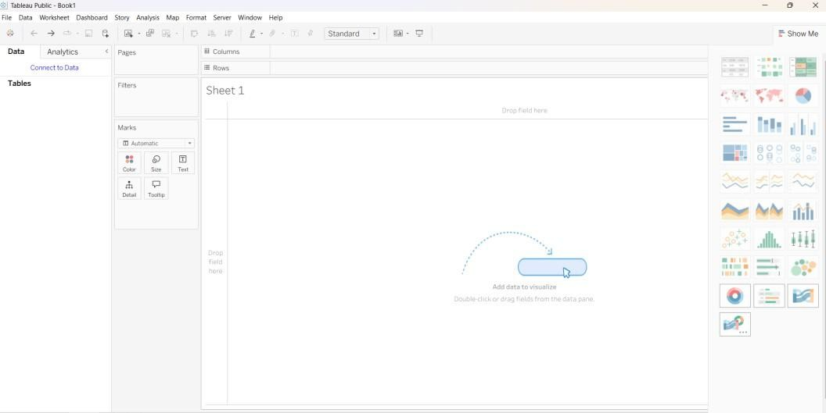

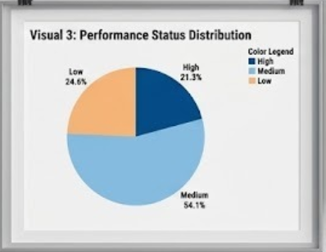

Imported dataset displayed in Data View:

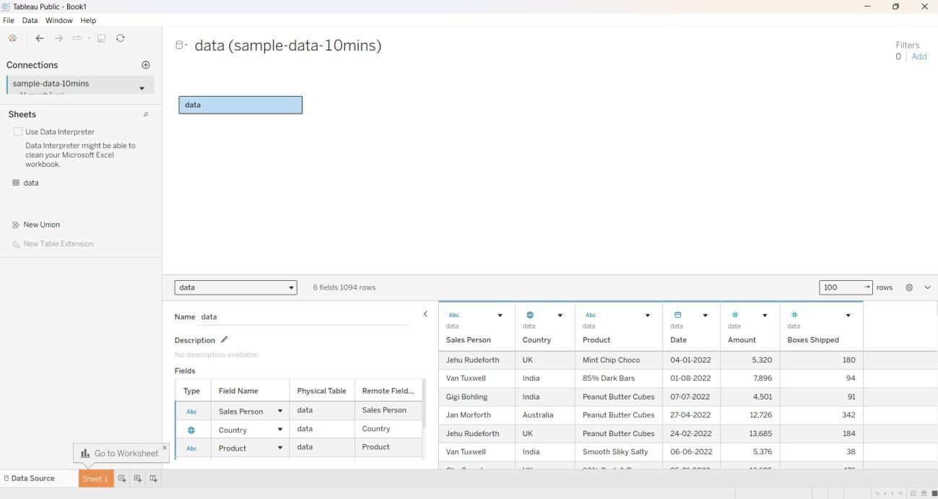

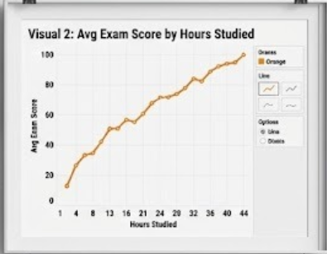

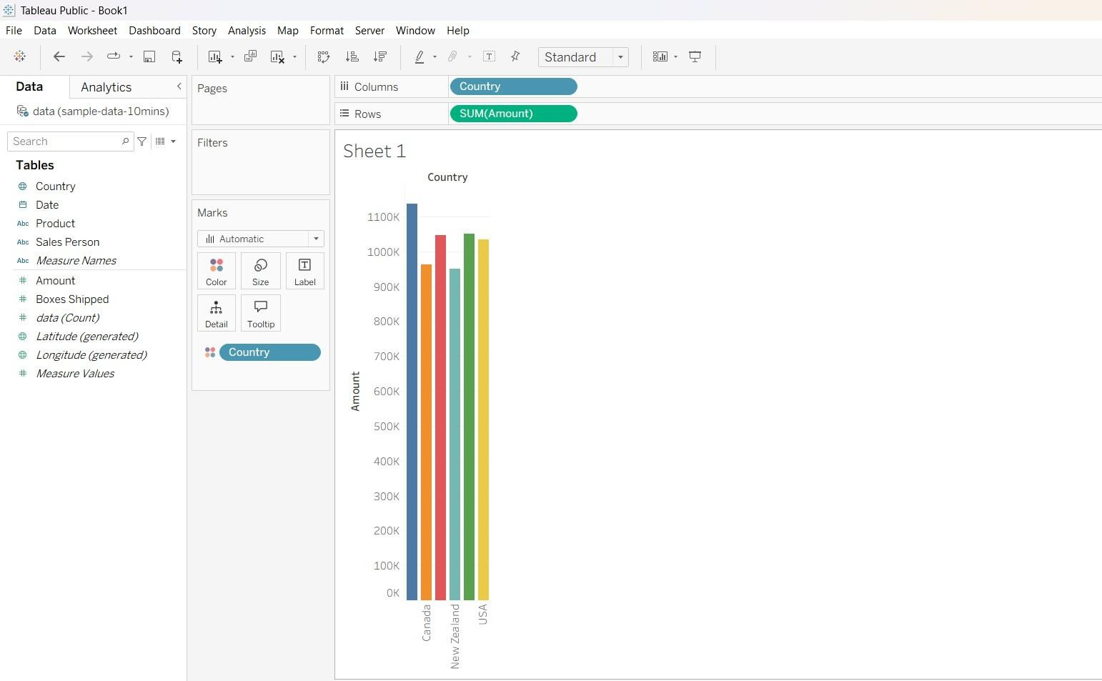

Making a Top 10 sales: 1).Apply filters:
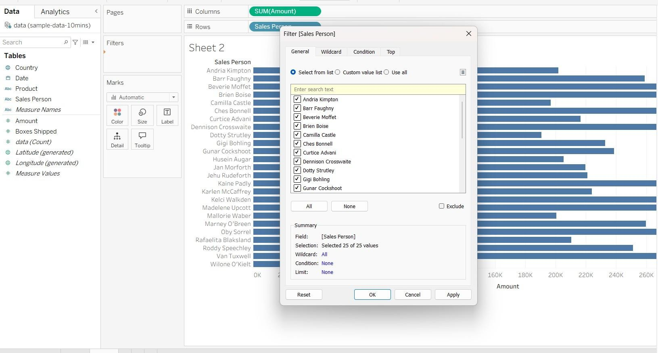

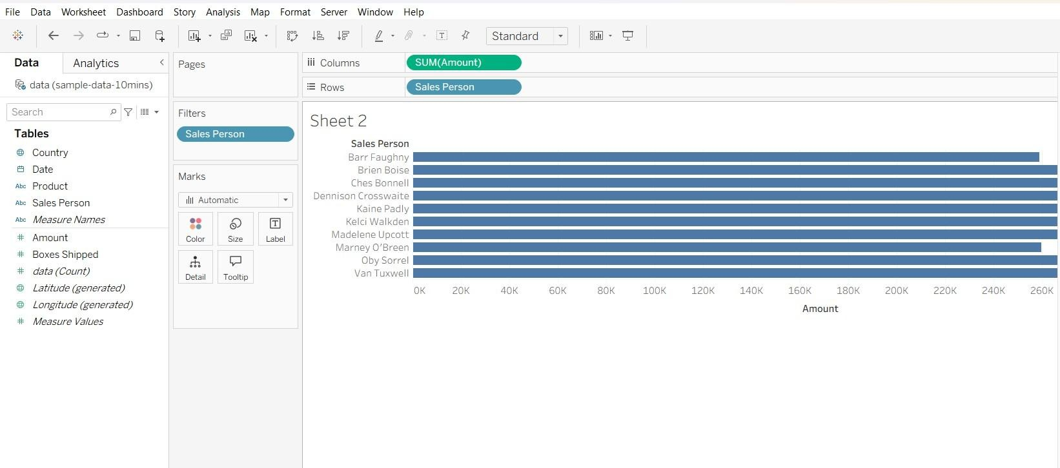

- Make DashBoard in Tabulaue:
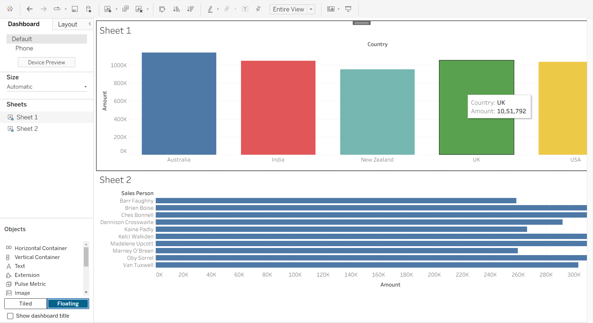

- Add Business Summary:

